Credit Card Default Model
Architecture Design
Shankesh Raju MS

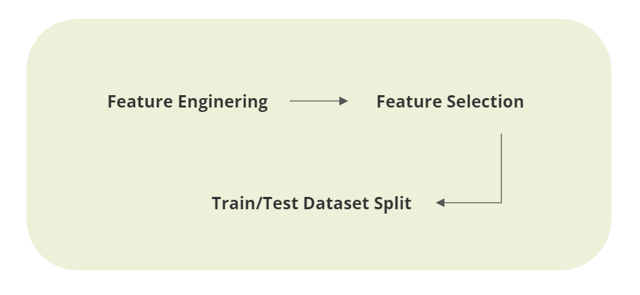
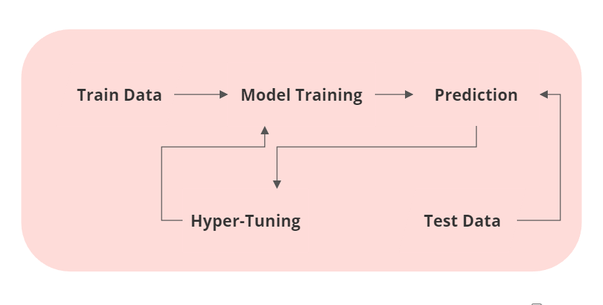
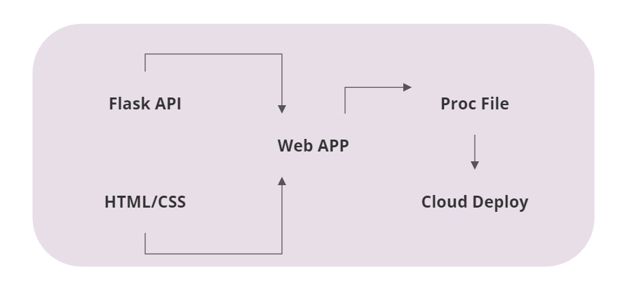
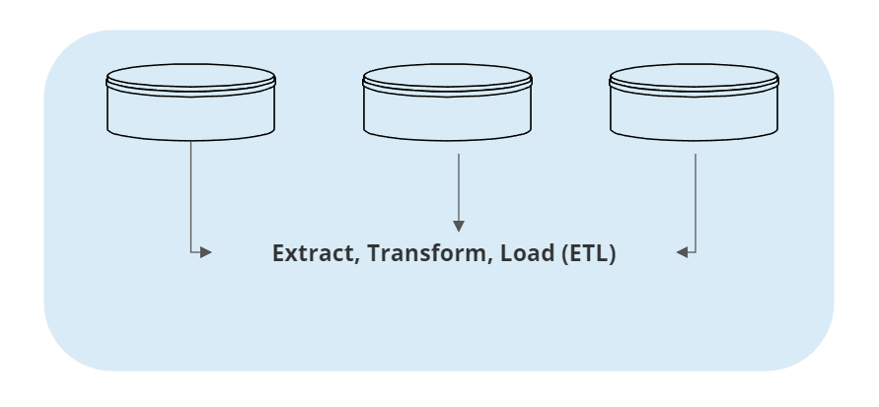
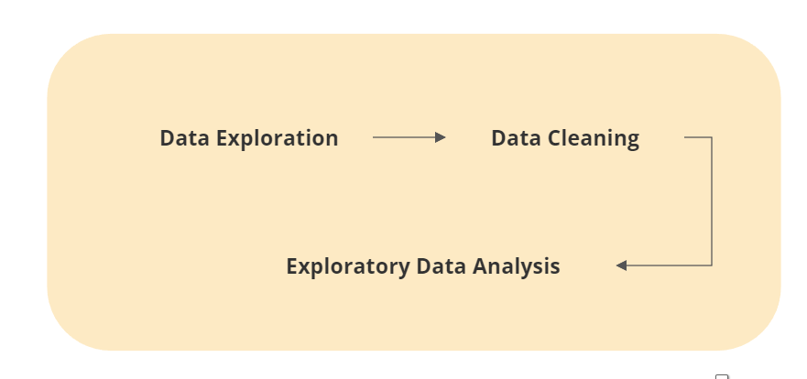
1.0 Architecture
2.0 Description
We have categorised our workflow into five sections based on the nature of work.
In first section we will gather data from multiple sources into a single database for initial transformation. The data is transformed into desired format requested by the entities and then loaded into multiple entities for further processing. Second section involves data exploration, means to see what type of data it has, how many features it has, any missing or garbage values, inconsistent data or presence of outliers. Data then undergoes cleaning process where all the above mentioned problems are rectified by replacing, filing or deleting the data entries without any data loss or data tamper.

Next step involves data analysis to study their characteristics and insights using statistical graphs and diagrams. This exposes the true content of what data has been hiding and will provide us the eagle eye view of connection between the features. Further we perform feature engineering to modify the columns for additional data to enhance our model performance. Selecting the features that matters to the model performance is an art. One has to study the data thoroughly to find the list of features important for model building. Later feature transformation happens for the data to be uniform distribution to feed into the model for training. Dataset is now partitioned into train and test, train dataset for the initial training, test dataset for testing the model’s performance and accuracy.

Once the preferred algorithm for our problem statement is chosen, model undergoes training with train dataset. If the model performs bad in testing it will undergo performance tuning to improve the accuracy and recall value. Our last section includes building a web application using Flask framework and deploying it in cloud. HTML/CSS style sheets are used to create web pages to host the front end Flask API to receive input from used and fed into the model to make prediction. Later we configure Proc file which holds the configuration for the cloud environment to run as web application and make the prediction. This model will be trained in multiple classification algorithms to find the best performer and will be further tuned to maximize the accuracy and performance.

